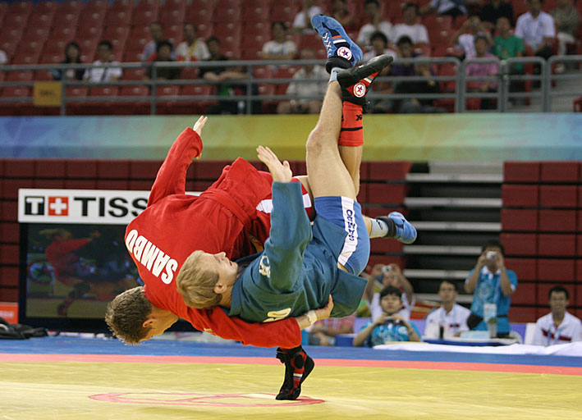

REGULATIONS
FOR ORGANIZATION AND STAGING OF THE FIAS OFFICIAL COMPETITIONS
(rules for sport and organization)

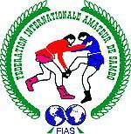

ADOPTED AT THE XXIII FIAS CONGRESS
on November 10, 2011, Vilnius (Lithuania)

REGULATIONS
FOR ORGANIZATION AND STAGING OF THE FIAS OFFICIAL COMPETITIONS
(rules for sport and organization)

CONTENTS

- GENERAL PROVISIONS | 3
- GLOSSARY (BASIC DEFINITIONS THAT ARE APPLICABLE IN THE REGULATIONS) | 3
- PREAMBLE | 5
- BASIC PRINCIPLES | 5
- CALENDAR | 6
- AGE GROUPS | 7
- WEIGHT CATEGORIES | 7
- DURATION OF BOUTS | 8
- METHODS OF CONDUCTING COMPETITIONS | 8
- FIAS MEMBERSHIP FEES | 8
- FIAS COMPETITION HOSTING CONTEST | 9
- APPLICATIONS FOR HOSTING COMPETITIONS | 9
- COMPETITION ORGANIZERS RESPONSIBILITY | 10
- FIAS RESPONSIBILITY | 13
- COMPETITION VENUE | 13
- STANDARD ARENA AND MAT REQUIREMENTS | 15
- ORGANIZATION OF FIAS COMPETITIONS | 15
- APPLICATIONS FROM PARTICIPANTS | 15
- ARRIVAL OF PARTICIPANTS, PRELIMINARIES | 16
- SAMBO DRESS CONTROL, PATCHES, ADVERTISING AND MARKING | 17
- WEIGH-IN | 18
- DRAW | 19
- COURSE OF COMPETITIONS | 19
- SEATING OF JUDGES AND SERVING PERSONNEL | 20
- COMPETITION OPENING, AWARDING AND CLOSING CEREMONIES | 20
- MEDALS, DIPLOMAS AND AWARD PRESENTATION | 21
- DOPING CONTROL PROCEDURE | 22
- MARKETING, ADVERTISING, PRESS AND TELEVISION WORK | 22
- TV BROADCASTING RIGHTS | 22
- PROVISION FOR MASS MEDIA ACTIVITIES | 22
APPENDICES | 24

- GENERAL PROVISIONS

- GLOSSARY (BASIC DEFINITIONS THAT ARE APPLICABLE IN THE REGULATIONS)
- Regulations — scope of rules that regulate the order of the competitions.
The Regulations of the International SAMBO Amateur Federation (FIAS) together with the Statute are mandatory documents for staging World Championships and all the competitions staged under the auspices of the FIAS.
- Calendar – document, where all the competitions for a certain period are listed with venues hereof and further details.
- FIAS Calendar – list of the top world class SAMBO sport competitions officially approved by the FIAS Congress with indication of dates and venues hereof.
- Official Competition - play for SAMBO championship within the FIAS Calendar aiming to reveal the winner and distribute the subsequent positions.
- World Championship - play for SAMBO championship within the FIAS Calendar aiming to reveal the winner and distribute the subsequent positions amongst different age groups and institutions. These Regulations stipulate the staging of competitions through the example of a SAMBO World Championship for adults (hereinafter referred to as “the Championship”). For all other competitions, this format will be used as the basic one with consideration of specific features.
- Bout – a wrestle of two SAMBO athletes, performed under the SAMBO competition rules.
- Outfit – sportsman’s clothing and gear necessary for training and contest practice.
- Judging rules – method of holding a contest adopted for a certain kind of sport in a relevant federation.
- FIAS Judging rules – FIAS official rules pursuant to which the best contest participant is defined among other SAMBO athletes or teams during a sport competition.
- Competition venue – complex of premises and courts necessary for holding contests (competition ring, warm-up gymnasiums, changing rooms, press-center, broadcast center, parking areas, exhibition areas, etc.).
- Secretariat – body within the Referees’ Board with following functions: preparation of competition paperwork, processing hereof and analysis in order to define the winners, formalization of final protocols, etc.
- Weighing of participants – establishing the compliance of the athlete’s weight to its claimed weight category.
- Medical control – set of measures aimed at health and life support of the contest participants. It includes medical examination of athletes, medical and pedagogical supervision, sanitary and hygienic control after the places and conditions of training or competitions, health-educational and cultural activities. The medical control is carried out by medical-and-preventive institutions of the healthcare system under the supervision of the FIAS medical board chairman (delegated or persons).
- Arena and matting requirements – list of conditions necessary for a proper holding of SAMBO tournaments. Such conditions are regulated by special requirements for such premises (construction dimensions, through-put capability of the arenas and stands, sizes and spotting of the necessary amount of sport equipment and gear, etc.).
- Opening, closing and awarding ceremonies – a set of specially arranged official procedures for SAMBO competitions.
- Participants’ accreditation – procedure of formalization of an official document for specific event that confirms the participant’s personality, his functional category and access area (athlete, coach, organizer, judge, team doctor, security service, FIAS staff, VIP, etc.).
- Competition running systems – method of running the SAMBO competitions.
- National hosting federation – SAMBO federation of the country, holding the championship.
- Organizing committee of the competition – body responsible for the competition planning and holding including providing the infrastructure and executive work.
- TV broadcasting rights – scope of all rights for TV broadcasting of the FIAS competitions. The TV broadcasting rights are property of the FIAS.
- Broadcasting organization - company, which the organizer made a contract for creation of an international television signal with.
- FIAS responsibilities - FIAS responsibilities before the national hosting federation.
- FIAS awards – list of official awarding attributes handed to the winners and runners-up of the FIAS competitions. It includes medals, diplomas and cups with the FIAS official insignia.
- FIAS media guidance – document regulating the cooperation with mass media during the FIAS events.
- FIAS television guidance – document regulating the cooperation with television during the FIAS events.
- FIAS advertisement guidance – a document regulating the advertisement work during the FIAS events.
- FIAS marketing guide – document regulating the marketing work during the FIAS events.
- FIAS anti-doping guidance – document regulating measures on prevention and detecting the presence of the prohibited drugs in the athletes’ bodies during the FIAS competitions. Is developed by the FIAS medical board on the basis of the WADA code and instructions.
- Competition contract – a treaty made between the host city, national federation-host and the FIAS.
- Competition application – document containing the list of participants with indication of their age, sex, sport qualification, weight category and medical permit. It is presented to the competition Organization Committee.

- PREAMBLE
2.1 The Regulation serves as an organizational guidance for all SAMBO competitions (at different levels: international, continental and national). No deviations from this document are allowed.
2.2 In the Regulation, the masculine gender is used in respect to any person (such names as representative, participant, competitor, athlete, judge, arbiter, service staff, pronouns such as he, they, them), which unless otherwise expressly stated, shall be deemed as including the feminine gender.
2.3 The Commission for the organization of competitions is incorporated into the FIAS department for sports.
2.4 The organization of the world championships is the object of control by the FIAS Management, the Management of the continental federation and national SAMBO federations that is the organizer of specific competition.
2.5 The national SAMBO federation shall present the composition of the world championship organizational committee. The national Federation is responsible towards the FIAS Executive committee for the provision of a proper level of world championship holding. The FIAS is the final appeals instance.
2.6 The national SAMBO federation hosting the official competitions shall develop proposals regarding organization hereof based on the FIAS Regulations and with due consideration of local conditions. The FIAS Executive Committee supports the hosts by presenting guidance documents, technical assistance and providing a relevant control.
2.7 FIAS controls the holding of the world championship and the work of the Referee Commission.

- BASIC PRINCIPLES
3.1 Official judging rules are applicable for all FIAS competitions: world championships, continental championships and all FIAS official events.
All amendments to the official judging events are adopted only on the FIAS Executive Committee decision.
3.2 Basic principle for the FIAS competitions
The FIAS is holding separate competitions for the male and female persons. Competitions between persons of different gender are not allowed.
3.3 Regional SAMBO competitions control
The FIAS exercises control over the regional SAMBO competitions where the world championship is supposed to be held according to the decision of the Executive Committee or Congress. This control suggests valuation of compliance of the federation activity with all regulatory documents: the Statute, the financial terms, the Regulation and the judging rules. During such SAMBO competitions, the judging and the technical matters are to be supervised by the executive persons appointed for the planned championship by the FIAS.

- CALENDAR
  - The FIAS Calendar is formed in strict accordance with the official competitions rating (tab 1). First approved are dates of the world championships for seniors, youths, juniors and cadets, world cups. With consideration of these events the continental federations approve the continental championship dates.
  - World championship: seniors (men, women and combat SAMBO) is staged every year in compliance with the calendar (at one and the same month).
4.2 World championship: youths (men and women under 20 years) is staged every year in compliance with the calendar (at one and the same month).
4.3 World championship: juniors (boys and girls under 17-18 years) is staged every year in compliance with the calendar (at one and the same month).
4.4 World championship: cadets (boys and girls under 15-16 years) is staged every year in compliance with the calendar (at one and the same month).
4.5 All the competitions staged within the FIAS international competitions calendar are official and classified in accordance with their rank in the international rating (tab 1):

Table 1
International rating of SAMBO competitions
Rank | Name of competitions
1 | World games (Sport Accord World Combat Games, Universiade, Student Games (13-14 years) etc.)
2 | World championship: seniors (men, women, combat)
3-4 | World championship: youths (for men and women of 19-20 years)
3-4 | World championship: juniors (for boys and girls of 17-18 years)
5 | World championship: cadets (for boys and girls of 15-16 years)
6 | World Cup (team, stages)
7 | Continental championships, all ages
8 | A series world tournaments
9 | B series world tournaments
10 | World championship: masters (veterans)
11 | World championship: institutions (students, police, army, firefighters, etc.)

- AGE GROUPS
All the FIAS contestants shall be divided into the following age groups (tab. 2):
Table 2
Age groups of the FIAS contestants
Group | Age
Schoolchildren (boys and girls) | 13-14 years
Cadets (boys and girls) | 15-16 years
Juniors (boys and girls) | 17-18 years
Youths (men and women) | 19-20 years
Seniors (men and women) | 19 and older
Masters (men and women) | 35-39, 40-44, 45-49, 50-54, 55-59, 60-64, 65 and older

Note:
In Accordance with the SAMBO competitions rules the competitors' admission is accomplished in accordance with the competition Regulations.
For the underage athletes the National federations shall obtain authorization from their parents.

- WEIGHT CATEGORIES
  - The SAMBO contestants are divided into weight categories depending on their age and gender (tab 3):
Table 3
FIAS contestants weight categories
Schoolchildren  (13-14 years) |  | Cadets  (15-16 years) |  | Juniors  (17-18 years) |  | Youths  (19-20 years) |  |  | Seniors  (18 and older) |  |  | Masters  (35 and older)
boys | girls | boys | girls | boys | girls | men | women | c/s men | men | women | c/s men | men | women | c/s men
35 | 34 | 42 | 38 | 48 | 40 | 48 | 44 | 48 | - | - | - | - | - | -
38 | 37 | 46 | 41 | 52 | 44 | 52 | 48 | 52 | 52 | 48 | 52 | - | - | -
42 | 40 | 50 | 44 | 56 | 48 | 57 | 52 | 57 | 57 | 52 | 57 | - | - | -
46 | 43 | 55 | 48 | 60 | 52 | 62 | 56 | 62 | 62 | 56 | 62 | 62 | 56 | 62
50 | 47 | 60 | 52 | 65 | 56 | 68 | 60 | 68 | 68 | 60 | 68 | 68 | 60 | 68
54 | 51 | 66 | 56 | 70 | 60 | 74 | 64 | 74 | 74 | 64 | 74 | 74 | 64 | 74
59 | 55 | 72 | 60 | 75 | 65 | 82 | 68 | 82 | 82 | 68 | 82 | 82 | 68 | 82
65 | 59 | 78 | 65 | 81 | 70 | 90 | 72 | 90 | 90 | 72 | 90 | 90 | 72 | 90
71 | 65 | 84 | 70 | 87 | 75 | 100 | 80 | 100 | 100 | 80 | 100 | 100 | 80 | 100
+71 | +65 | +84 | +70 | +87 | +75 | +100 | +80 | +100 | +100 | +80 | +100 | +100 | +80 | +100
*c/s – Combat SAMBO.
6.2 In the junior and senior groups (men and women) the competitions for the Absolute Champion may be held without competitors' distribution into weight categories. Minimum weight in such competitions shall be stated in the Regulations (Appendix 1).

- DURATION OF THE BOUTS
7.1 The duration of the bout shall be as follows:
- for seniors and youths (men), sport and combat – 5 (five) minutes;
- for seniors and youths (women) – 4 (four) minutes;
- for juniors and cadets (boys and girls) – 4 (four) minutes;
- for schoolchildren (boys and girls) – 3 (three) minutes;
- for veterans: men – 4 (four) minutes, men over 60 - 3 (three) minutes, women – 3 (three) minutes, combat (men) – 4 (four) minutes.
7.2 Counting out the time of the bout begins at the first sound of the referee’s whistle and finishes at the sound of gong (siren). The time of breaks is not included in the actual time of the bout.
7.3 In extreme situations it is allowed to include the time of breaks, not accompanied by the referee’s gesture “Stop the time!”, in the actual time of the bout (except semi-finals and finals) if it is stipulated in the Regulations of the competitions.
7.4 If it is necessary, the contestant may, with the referee’s permission, put his dress in order (tie the belt or laces). For this procedure he is given time not exceeding in total 1 (one) minute during one bout. The time for replacement of torn jacket or shorts being an exception. If necessary to replace torn shorts the athlete, accompanied by the side referee, departs to a closed compartment and changes them.
7.5 In case of an injury the contestant is given not more than 1 (one) minute in the course of bout. The medical assistance is rendered directly on the mat (edge of the mat).
7.6 The rest period in between the bouts shall not be less than 10 (ten) minutes for seniors and juniors and not less than 15 (fifteen) minutes for schoolchildren and youth.

- COMPETITION SYSTEMS
  - All the FIAS competition systems are presented in the SAMBO Competition Rules and are stipulated in the Regulations of the competition.
8.2 When the number of participants is 4 (four) or less, a circular system is applied.
8.3 The order of encounters between participants (teams)) id defined by a draw.

- FIAS MEMBERSHIP FEES
  - A single annual membership fee from a national SAMBO federation to the FIAS is 300 (three hundred) USD and shall be paid duly to FIAS before January 10 of the payable year.
  - Each participant of international FIAS SAMBO championship shall have a properly executed FIAS license book and FIAS identity card issued by FIAS upon the athlete’s first registration.
  - The price of the FIAS license book is 10 (ten) USD. The license book shall include registration of annual license pay charged for participation in FIAS international SAMBO competitions. The price of the annual license for participation in FIAS official competitions for all categories of athletes (seniors, veterans, youths (19-20 years)) is 25 (twenty-five) USD.
  - The athlete’s annual license fee is to be paid by the corresponding national federation within 1 month prior to the competitions. Payments are made by bank transfer to the FIAS account or any other pay method approved by the FIAS Treasurer.
  - Athletes who fail to have paid the FIAS annual license in due time or carry no FIAS license book may pay their annual license upon arrival at FIAS international competitions. They are also charged 25 (twenty-five) USD fine.

- CONTEST FOR A RIGHT TO HOST THE FIAS COMPETITIONS

- APPLICATIONS FOR HOSTING THE COMPETITIONS
10.1. A national federation that is a member of the FIAS may apply with a competitive bid for hosting an international SAMBO championship. A continental federation must approve the bid before that.
10.2. The application shall be submitted to the FIAS President within 4 years prior the planned international competition.
10.3. FIAS Executive Committee considers the applications for hosting international SAMBO competitions, draws a list of 2 (two) candidate countries for hosting an international competition and tables the proposals for approval to the FIAS Congress.
10.4. The application of candidate organization for hosting an international SAMBO competition shall include the following documents and information:
10.4.1. An official letter for the attention of the FIAS President, specifying:
  - name of the event;
  - precise dates of the event to be hosted;
  - information of the venue (city);
  - detailed information of the sports venues (gyms) and other corresponding facilities;
  - detailed information of the places of accommodation (terms and conditions of stay, pricing);
  - information of financial guarantees for national federations;
  - information of financial guarantees for sponsors.

10.4.2. Attachments to the application include:
a) Presentations of the venue (country/city), link to the city web-site if available (including information about weather conditions for the period of competitions, local currency, work hours of local banks, hotel information – name, location, distance to the airport and competition venues, infrastructure, additional services, hotel pricing (full board and room only) per day, availability of telephone connection and the Internet – a link to the hotel web site if available; airport name and location);
b) Presentation of sport venue to hold the competitions, including technical characteristics;

10.4.3 Registration fee.
National federation-bidder, along with submitting the application, must transfer a 1000 (one thousand) USD registration fee to the FIAS bank account
The funds received as a result of transferring the registration fee are not returnable and are used for performing inspectional travels of a technical delegate to the venues of future events.
10.4.4 Holding guarantees
The FIAS performs the event readiness inspection not later than 2 (two) years prior to the championship. After the inspection the national federation winning the contest for hosting the international SAMBO competition and the FIAS make a Contract where penal sanctions for non-performance of obligations are provided. The Contract is made 1 (one) year prior to the championship.

11. RESPONSIBILITIES OF THE HOST ORGANIZATION
11.1 The National federation that got the right to host the World SAMBO championship or cup on the competitive basis, must:
a) form the Organizing Committee for preparation and conduct of the competitions;
b) elaborate a detailed program of arrangements to hold the sports event;
c) submit a financial plan with the analysis of all the expenditures necessary for holding the competitions in question.
11.2 The program of the competitions and financial plan has to be submitted to the FIAS Executive Committee for the approval not later than 1 (one) year before the start of the competitions.
All subsequent changes, proposed by the hosting organization after the approval must be agreed with the FIAS Executive Committee.
11.3 The President of the host organization acting as the event organizer is taking personal responsibility for the preparation and running of the championship or the world cup to the FIAS Executive Committee.
11.4 The FIAS Sports Department has the right to delegate the Chairman of the sports technical commission to the Organizing Committee to provide practical assistance.
11.5 Personnel and equipment
The National Federation organizing the Championship preparation provides the necessary personnel and equipment as stipulated in the FIAS Regulations requirements.
11.6 Congress and meetings
At staging a world championship the National Federation also provides necessary facilities for holding a FIAS Congress, sessions of continental federations, Executive Committee, FIAS departments at their prior request. At holding the FIAS Congress the organizers will provide synchronous interpreting into the FIAS official languages (mandatory in Russian, English, French, Spanish).
11.7 Financial obligations
The Organizational Committee of the national federation (the organizer) fulfill the financial obligations mentioned in the Contract, made between the FIAS and national federation.
11.8 Transportation
The organizers are to provide means of transportation for arrival and departure of the representatives and participants between the railway station (or the airport) and their place of accommodation as well as between the event venue, the warm-up gyms and places of accommodation. The transportation is only provided for those participants who stay in the official hotels, suggested by the organizational committee.
For use of the transfer the participants shall pay a lump-sum payment of 20 (twenty) USD per each member of the delegation.
Certain vehicles shall be provided for all period of the championship at the expenses of the Organizational committee:
- 1 car for the President;
- 1 car for the Secretary General and 1st Vice-presidents;
- 1 car for the Executive director and Senior treasurer;
- 1 car for the Head of the sports Department, Chairman of the Referee Commission, Chief Referee and Chief Secretary of the competition;
- 2 mini-buses for the members of the Executive Committee;
- 1 bus for the referees.

Note: the above requirements are related to staging the official world championship and other FIAS events, they are to be mentioned in specific contracts.
11.9 Anti-doping control
The national federation organizational committee takes all necessary measures to perform the anti-doping control and assurance so that the athlete samples underwent analysis in the IOC and WADA-accredited or approved laboratories.
11.10 Entry to the country of the event
The National Federation hosting the Championship is to assist via the government authorities those representatives of national federation and athletes wishing to participate in the competition in presenting a respective possibility of entry and departure from its territory. The National Federations shall respect the consular requirements to the visa time parameters.
11.11 General Program
The National Federation hosting the Event must elaborate on the basis of the Regulations a detailed program holding all the dates, events and venues related to the Championship organization. This program must be agreed with the FIAS Commission in charge of this championship 6 (six) days prior to beginning of the championship. The Program is sent to each participating National Federation and all the FIAS staff members 30 (thirty) days prior to the date of arrival.
The renewed program must also be given to each National Federation, members of the Executive Committee and the FIAS staff members on their arrival.
11.12 Accommodation
The Organizer will report the National Federations of the accommodation and nutrition conditions three months prior to the date of the world championship. The report must include the information regarding the level of the hotels (minimum three). To provide normal accommodation the hotels shall be of decent level.
Hotel requirements – minimum 3 (three) stars + two meals (breakfast & supper). All this is covered at the rate of 100 (one hundred) USD for one person per day.
The National Federations must give the official confirmation of the composition of delegation, provide the flight numbers and advise on the necessity of welcoming 1 (one) month in advance.
The Organizational Committee at prior request must provide special nutrition for the event participants with consideration of their national and religious cuisine peculiarities.
For non-official delegation members who plan to accommodate on their own the organizers must propose hotel options (with addresses and description of conditions) and receive 150 (one hundred fifty) USD per person as an accreditation fee.
The Organizational Committee provides for the period of Championship the accommodation of the FIAS President, Secretary General, 1st Vice-presidents and Vice-presidents.
11.13 FIAS Treasurer requirements to the national hosting federation
The National federation that is hosting the FIAS line competition provides a necessary working place and equipment (copy machine, printer) for the FIAS Treasurer (Assistant Treasurer).
The execution of a FIAS license book takes place during the work of the registration commission, and each participating delegation must be informed in advance hereof.
To execute the license books the leader of each arrived delegation must present the FIAS Treasurer with a list of the athletes participating in the competitions to define the athletes who had previously obtained the license for the current year at other FIAS line competitions. It is also necessary to present a payment receipt for FIAS annual membership fee.
Each participant arriving for execution of the FIAS license books must carry the passport as well as the license book, if available, previously received at the FIAS line events.
If the participant had paid the license fee for the current year non-cash – by a funds transfer to the FIAS bank account, it is necessary to present a copy of the payment order marked by the bank.
The FIAS Treasurer must present each competition participant a payment receipt for the license book (annual license).

12. FIAS RESPONSIBILITY
12.1 The FIAS responsibility begins from choosing a National federation to be the host of the FIAS calendar competition. This choice is made after analysis of the bids from prospective organizational committees (OC) with consideration of financial and operational aspects as well as the matters of TV broadcastings.
12.2 FIAS appoints different delegates who are responsible for different aspects of the competitions: organizational, technical, press, medicine, television.
12.3 FIAS supports the Organizational committee of the national federation at preparations of the world championship.
FIAS will cover payment for the reception of the referees, appointed by the Chairman of Referee Commission (accommodation, nutrition, work (50 (fifty) USD per day)); provides travel, accommodation, nutrition, work (100 (one hundred) USD per day) for the Chairman of the FIAS Referee Commission, Chief Referee and Chief Secretary with consideration that they arrive one day earlier and leave one day later of the official terms of the competition; will cover payment for the procedure of doping control of the athletes at the official competitions at the suggestions of the Chairman of the Medical Commission.
FIAS at the suggestion of the Organizational Committee approves the design of the awarding attributes (medals, diplomas, cups).
12.4 To control the progress of preparations and to provide practical assistance the FIAS President appoints a commission. The commission submits a report to the FIAS Board and the FIAS Executive Committee two years, one year and half a year before the beginning of the championship.
12.5 The FIAS Secretary General six months prior to the world championship will send to the SAMBO national federations official invitations, preliminary program, general remarks on organization, rules and forms of applications.
12.6 The FIAS Treasurer on the basis of the Statute, financial rules and the Regulations is preparing a Contract between the FIAS and the national federation after the appointment of the candidate.

13. COMPETITION VENUE
13.1 The sports venues for holding the championship shall be of imposing character and shall be big enough to facilitate the provision of all necessary conditions and have no less than 2000 (two thousand) seats for the world championships. The hall arrangement shall be as required by the Regulations (Appendices 13-16).
13.2 Hygienic requirements for the SAMBO competition venue.
- The daylight factor of the hall shall be not less than 1:6; the artificial light – not less than 100 luxes. The mat shall be lighted from above by the reflected or diffuse light lamps with protective mesh screens.
- At holding the competition indoors the temperature shall be between +15 and +25 degrees C°, the air humidity – not less than 60%. The ventilation shall provide a triple air change per hour.
- At holding the competition outdoors the temperature shall be between +15 and +25 degrees C°. The mat shall be protected from direct sunlight.
13.3 The venue for competition and the adjoining territory shall be protected from unauthorized access. There shall be a sufficient amount of seats for the members of the FIAS Executive Committee, Sports Technical Department, referees, service staff, physicians (approximately 70 persons)
A certain amount of seats shall be reserved for the guests of honor, the President and Secretary General, leaders of the participating national federation delegations, journalists.
The seats for participants shall be placed as close as possible to the competition area.
It is necessary to provide a possibility of unrestricted movement of the doping control service workers in the competition area.
13.4 To host a world championship the sports venue shall have available a warm-up gym in area of minimum 600 square meters.
13.5 Each mat shall be equipped with two electronic indicator boards (Appendix 15), best spotted to view all categories, a spare indicator board, a manual indicator board, stop-watches, gongs, etc. that are provided by the organizers in accordance with the judging rules.
13.6 At each mat video cameras are spotted with monitors for the judges to review the disputable situations of a bout with participation of the Chief Referee or Deputy Chief Referee (Appendix 15).
13.7 The organizers provide tables for at least ten persons nearby each SAMBO mat (the FIAS sports department specialists among them). The representatives at the table shall work independently from other objects.
Except tables nearby the mat there shall be organized a central desk for the jury of appeal which is to be equipped with a microphone for announcements. There shall be 2 (two) tables for the physicians, out of the camera angle but within sight from the mats.
A table is necessary at the athletes’ entrance for the participants’ uniform control in the competition area.
The organizers shall provide special stands for the athletes where the protocols of the course of competitions for different mats will be presented.
13.8 There shall be available lockable cloak rooms, a first aid room, massage tables, premises for recreation of the sports and referee commission, the referee, a working room for the press, a canteen.
Other information regarding the material and personnel requirements is set forth in the Appendices 5 and 7.
13.9 The Chief Referee and the head of the FIAS sports department must (in order to check the availability and workability of the necessary equipment and means of connection) check the readiness for the competition of the premises, equipment and outfit, their compliance with the International SAMBO Rules, draw a Statement of acceptance of the competition venue and also make sure that the necessary papers are available. (Appendix 6).
13.10 The organizers must provide in the sports hall seats for the participants, guests, official persons, press and TV representatives. The access to the sports hall is allowed by accreditation only.

14. STANDARD REQUIREMENTS FOR THE COMPETITION AREA AND MATS
14.1 The size of the mat for SAMBO competitions shall be 12x12 meters. The central surface (“working area”) of the mat where the bouts are conducted is the circle 9 meters in diameter. The width of the protective (safety) zone (the rest of the mat) shall not be less than 2,5 meters in any point of the circle.
The mat, made of synthetic fabric, shall be smooth and not less than 5 centimeters thick and of a density 140 kg/m³.
The center of the mat is marked with the circle 1 meter in diameter; the width of bordering line shall make 10 centimeters.
The whole surface of the mat shall be covered with the coverlet made of firm soft fabric or some synthetic material without rough seams. The covering shall be tightly stretched and fastened. The covering shall be disinfected.
Two opposite corners of the mat are marked with red and blue colors (red – to the left of the officials’ table, blue – to the right).
14.2 To prevent injuries the floor near the mat shall be covered with a soft material, carefully fixed in place (or gymnastics mats) with the width not less than 1 meter, not less than 5 centimeters thick and not thicker than the mat itself.
The platform where the mat is placed shall be up to 2.5 meters wider than the mat on every side. The equipment positioning diagram is described in the Appendix 15.
To avoid any injuries at the distance of 2 meters around the mat there shall be no strange objects. Spectators shall be seated at the distance of 3 meters from the mat.
14.3 During the competitions, held on the platform, its height shall not exceed 1 meter. The sides of the platform shall have 45⁰ outside incline.
14.4 The suitability of the mat and equipment for the competitions is defined by the Chief Referee, the doctor and representatives of the organization conducting the competition. The mat suitability is recorded in a special reception statement (Appendix 6).

- ORGANIZATION OF COMPETITIONS

15. APPLICATIONS FROM PARTICIPANTS
15.1 The national federations participating in the competitions under the FIAS auspices shall present the preliminary applications (number of participants) three months prior to the date of competition. The final application (names, weight categories, athletic feats) is presented 10 days prior to the beginning of competition by means of an obligatory online registration in the FIAS site.
15.2 For all age groups, events and gender of participants there is allowed at the championships one contestant for each weight category. At the world cup competitions and A and B category tournaments it is allowed for more than one participant from a country to take part (in accordance with the Provisions)
15.3 The athletes may only be staged in their claimed weight category.

16. ARRIVAL OF PARTICIPANTS, PRELIMINARIES.
16.1 The information, the booklet and the information desk
Throughout the championship from the moment of the first delegation arrival and down to the very last day of the championship the Organizational Committee of the National Federation is to distribute all the central office participants among several hotels where they shall provide all delegations with information that is necessary for the stay and participating in the world championship.
An Information stand of the organizational committee with the representatives shall be organized in the main airports and railroad stations at the time of arrival of the national federations, greet all delegations and provide information regarding further transportation.
The information and application receipt office addresses and telephone numbers are sent to the national federations and the FIAS officials at least ten days prior to the championship.
The offices shall be open 24 hours a day at least on the days of arrival of the delegations.
16.2 Registration
The registration of participants is executed in accordance with the diagram set forth in the Appendix 3.
The team representative with a set of necessary documents (passport, participant’s license, insurance, medical control card), receives a queue ticket and waits in a specially designated area.
At first stage the team representative verifies the delegation members against the list from the preliminary application and performs the participants’ nationality control (by presenting passports). If the athletes from this team are not included into the FIAS members electronic database, they are photographed and fill up the questionnaires. The final team list is endorsed by the FIAS representative.
Then the team representative pays the necessary FIAS fees (or verifies the financial documents).
At the next stage the Organizational Committee receives money for nutrition, accommodation, transfers and issues the accommodation placement and meal coupons.
The organizational committee verifies with the representative the propriety of the national flags portrayal and the sounding of the national anthem of the country.
Finally the representative receives accreditations for the whole team and informational materials regarding the Championship.
16.3 Accreditation.
For each member of an official group from the national delegations (athlete, coach, representative, physician…) FIAS issues an accreditation card during the official registration. This card contains: a surname and a name, a FIAS identification number, a photo, a country and additionally for the athletes – a weight category.
This accreditation card is valid throughout the period of championship and serves for all situation as an athlete’s identification document. Free of charge accreditation is issued by an official representative provided the following conditions are met:

Number of athletes in the delegation | 1-2 | 3-4 | 5-6 | 7-8 | 9-10 | 11-12 | 13-14 | 15-16 | More than  16
Number of free accreditations | 2 | 3 | 4 | 5 | 6 | 7 | 8 | 9 | 10
If the number of official representatives is exceeded it is paid at the rate of 100 (one hundred) USD per each accreditation.

16.4 Citizenships
The athletes shall have the same citizenship as the National Federation they represent. Persons appointed by the FIAS Executive Committee verify the athletes’ citizenship. The proof of the citizenship will be the passport issued by the country the athlete is caped for.
16.5 Insurance and civil responsibility
Each National Federation shall take all responsibility for injuries and medical insurance as well as civil responsibility for their athletes and representatives, including the appointed referees during the world championship.
The competition organizers shall provide the insurance of the event.
16.6 Anthems and flags
The organizers present anthems and flags, the delegation leaders shall verify the compliance of the attributes presented with their country of origin
The flags shall be made horizontal, dimensions being 180x120 cm. There shall be available at least 2 (two) flags. For the world cup stages and A category tournaments there shall be more than 2 flags.
FIAS shall present to the organizers a collection of shortened versions of the anthems of the national federations-participants of the Championship on electronic materials.
16.7 Trainings
The hosting Federation provides training halls and transportation there and back for all the athletes. The time of trainings shall be coordinated between the delegations and incorporated into the schedule.

17. SAMBO UNIFORM CONTROL, PATCHES, ADVERTISING AND MARKING
17.1 Competitor’s dress
17.1.1 Competitor’s dress: SAMBO jacket, SAMBO shoes, SAMBO shorts (Appendix 8).
- Besides, the male participants may wear a protective athletic supporter or non-metallic groin-guards and females – the bra and a t-shirt (the t-shirt shall be single-colored white).
17.1.2 For combat SAMBO competitions, the athletes use additional protective gear (Appendix 9):
- SAMBO helmet;
- Gum shield;
- Groin guard (hard);
- Combat SAMBO gloves (hitting-gripping);
- Leg pads covering the front part of the shin and lacing of the SAMBO shoes.
17.1.3 For the official FIAS competitions, the whole athlete uniform (SAMBO jacket, SAMBO shoes, SAMBO shorts including outer protective gear) shall be of single color – red or blue. The uniform control referees shall provide for such compliance.
17.1.4 The uniform size compliance is verified by the uniform control referees using a special ruler in accordance with the FIAS competition rules.
17.2 Participant’s dress for opening and awarding ceremonies
Competitors shall appear for the Opening and Awarding ceremonies wearing red SAMBO uniforms.
17.3 Forbidden accessories in the participant’s dress
It is forbidden to wear during the bout rings, bracelets, ear rings, chains and other objects that might cause injury to the opponent.

18. WEIGH-IN
18.1 The object of the weigh-in is to state the correspondence of competitors' weight to the limits of one of the weight categories. A competitor has the right to compete at the given competition only in the weight category stated for him at the weigh-in. A competitor who is late to the weigh-in or misses it is not admitted to the competitions.
18.2 Official weigh-in is held one day before the competitions, the order and time is stated in the Regulations signed by FIAS President and the President of the National federation hosting the event.
During 1 hour before the start of the weigh-in contestants are allowed to get on the scales used for the official weigh-in as many times as they wish.
The weigh-in lasts 1 (one) hour.
18.3 In case the competitions are held during 2 days the weigh-in is held every other category, starting with the lesser one (e.g. men 52…62…74…90… +100; women 48…60…72 and so on).
If the competitions are held during 3 days, then the weigh-in is held every two categories, starting with the lesser one (e.g. men 52… 74…100; women 48…60…72 and so on).
18.4 The weighing procedure for each weight category is held only once, before the competitions of the same weight category. No additional weigh-in on the day of the competitions is allowed. The organizers shall foresee the electronic scales for athletes to control their weight at the places of their accommodation.
18.5 Weigh-in is held on electronic scales approved by FIAS. Athletes are admitted to the weigh-in procedure only upon showing their accreditation card.
18.6 It is allowed to use several scales but competitors of a certain weight category shall be weighed on the same scales.
18.7 The weigh-in shall be held by referees’ team appointed by the Chief Referee including a Deputy Chief referee (one of Mat chairmen), a representative of the competition secretariat, a doctor and two or three referees.
18.8 Before the weigh-in all the competitors shall undergo appearance medical control held by the competition doctor.
Competitors shall be weighed in a special room or behind the screen, half-naked: men wearing athletic supporters, women-low-necked swimsuits.
18.9 At the weigh-in a competitor shall submit the accreditation document with a photo (or a passport in case the accreditation document bears no photo).
18.10 Results of the weigh-in are entered in the score sheet that shall be signed by all the members of the team.
18.11 The world championships and all the FIAS competitions provide separate rooms for men and women which shall be available for non-official and official weigh-in.
18.12 The Chief Referee of the competition shall be responsible for weigh-in.

19. ATHLETE CASTING
19.1. The chief referee is responsible for athletes’ casting.
19.2 The casting shall be conducted in two possible ways:
Way one: the casting due to weight categories shall be done during the day of weighing. As soon as the weighing is completed each athlete shall draw his lots. The athlete will get the place in the participating group due to the drawn lots.
Way two: the casting due to weight categories shall be done during the day of weighing using a computer program.

20. COURSE OF COMPETITIONS
20.1 The competitions are held in accordance with the Competition Regulations (Appendix 1).
20.2 The competitions are held by the unified time regulations (Registration Commission, meeting of the representatives, weigh-in, the start of the competitions, conduct of the evening part, Opening and Closing ceremonies).
20.3 Recommended time for conducting of the separate parts of the competition.
- Registration commission: on the day of the arrival (one day before the start of the competition) – 10:00 to 16:00 (may be possible to start the work of the commission earlier depending on the certain conditions).
- Meeting of the referees: 16:00 to 17:00.
- Meeting of the representatives: 17:00 to 18:00.
- Weigh-in: 18:00 to 19:00 for the participants of the first day of the competition, 15:00 to 16:00 – during the competition.
- Casting: Way 1 - during the weigh-in; way 2 - after the weigh-in.
- Start of the competitions: 10:00.
- Opening Ceremony: 17:30.
- The evening part: 18:00.
20.4 The time for separate parts of the competitions may be changed on agreement with the Head of the FIAS sports department at the regulation creating stage.

21. COMPOSITION OF THE REFEREE BOARD AND SERVING PERSONNEL

21.1 The composition of the Referees’ (Referee) Board is appointed by the FIAS Referee Commission. The work of the Board is regulated by Part 3 of the International SAMBO Rules.
21. 2 The country participating in the official competitions that brings in 5 and more participants shall provide a referee who took part in the international seminar for sport judges and got a license.
21.3 To make the officials’ work successful, the organizers must provide the Officials’ Board with the serving personnel:
- interpreters to translate all announcements into at least two FIAS official languages;
- courier to deliver the minutes of the competition course to the secretariat;
- courier to deliver the minutes to the Chief Referee table;
- two electronic engineers to make the work of computers and the electronic board continuous;
- 4 (four) volunteers in a uniform dress for each of the mats to accompany the athletes to the bout;
21.4 The Organizational Committee of the competitions has to provide the continuous work of the serving personnel as well as the work of security.

22. CEREMONIES FOR OPENING, AWARDING AND CLOSING OF THE COMPETITIONS
22.1 Organizers have to prepare the Ceremonial Opening:
a) Delegations of countries - participants of the competitions line up in the alphabetical order with their national flags and the tablets with the names of the countries facing the main television camera.
b) The team of the country playing host to the competition comes to the parade last.
c) The Referee Board takes the seats in accordance with distribution to the mats opposite participants.
d) Under the sounds of the national anthem of the country – organizer its state flag is raised.
e) President of the country or the Chairman of the Organizing Committee welcomes all the people present at the Ceremony. Then the floor is given to FIAS President.
f) The FIAS President officially opens the competitions.
22.2 After the finals in every weight category all the athletes of the given category who won the prize places, clad in the SAMBO uniform of red color, gather in the place defined by the organizers for the awarding ceremony. The volunteers provide the presence of the athletes in the ceremony, seat them according to their weight categories on the chairs in the award preparations area.
The Referee Board takes the seats defined by the organizers.
The announcer pronounces the last name, name, country and after that the athlete stands on the podium according to the place he took. The order of the announcement: the third place (two winners successively), the second place, the winner.
22.3 Two official persons, appointed and informed in advance take part in the awarding ceremony (they are accompanied to the place of ceremony by two volunteers from the awarding group). One of the ceremonial group representatives hands in a medal, the other one – a diploma and flowers.
The FIAS President together with the President of the host national SAMBO federation shall award the winners in team classification. Presidents of National and Continental federations, guests of honor and sponsors award the winners in individual classification.
Upon the prizes have been presented to appropriate athletes - each corresponding national flag shall be raised, simultaneously with each corresponding national anthem sounding during the ceremony
Upon the last weight category has been awarded the President of FIAS declares the events closed (the members of Executive board shall stand opposite the participators of the SAMBO events). After this, the national flag of the host country together with the flag of FIAS shall be drawn down, all must be done to the national anthem of the host country.
The FIAS flag shall be forwarded to the delegate of the host national SAMBO federation, responsible for the next world championship or cup.
22.4 On the final day of the competitions the head of the FIAS Referees’ Board shall hold a referee meeting where the best referees are awarded due to the results of the event.

23. MEDALS, DIPLOMAS AND PRESENTATION AT THE AWARDING
23.1 The receiving organization is obliged to prepare awarding attributes for every weight category including:
- a set of medals for every weight category – 1 gold, 1 silver и 2 bronze;
- a set of diplomas (according to the taken places);
- valuable or money prizes for the prize-winners.
23.2 For evaluation of the results of team championship receiving organization is obliged to prepare the Cups for the 1st, 2nd, and 3rd places for each age groups (men, women, combat, youths, juniors).
  - In team competitions it is necessary to foresee the Cups for the 1st, 2nd, and 3rd places.

24. DOPING CONTROL PROCEDURE
24.1 Two (2) athletes shall go through a doping test: one gold medal winner and one of the three other winners (by means of a draw).
24.2 Those medal winners who are going through the anti-doping control procedure shall, after the awarding ceremony for their weight categories, arrive to a specially assigned place accompanied by a volunteer.
24.3 After the doping-control procedure the organizers shall provide the athletes and their escorts with transportation to their hotels.

IV. MARKETING, ADVERTISING, WORK OF PRESS AND TELEVISION

25. TV-BROADCASTING RIGHTS
25.1 FIAS owns exclusive rights for the Championship coverage by means of the image and (or) sound transmission in any way or using any technologies as well as by means of making a recording of the mentioned transmission and (or) photographing of the events.
25.2 Rights for the Championship coverage may be executed by the third parties only subject to the FIAS permissions or written agreements on purchasing the rights in question by the above third parties from the FIAS.
25.3 The Championship organizational Committee shall provide the TV-broadcasting of the event in compliance with the FIAS television guidance which in strict accordance with the International Olympic Committee (the IOC) and the International Sports Press Association (AIPS) requirements describes the interrelations between the FIAS, National Federation hosting the event, broadcasting organization and the TV organizations accredited at the event.

26. PROVISION FOR MASS-MEDIA ACTIVITIES
26.1 Considering the importance and the role that the work of mass media representatives plays in the SAMBO development around the world, the Event organizers provide for creation of the necessary conditions for the work of the press in accordance with the FIAS media guidance.
The principal requirement of the given guidance is creation of the modern conditions for the professional work of the accredited press in accordance with the AIPS regulations, the AIPS being the FIAS official partner (subject to the agreement on cooperation between the AIPS and the FIAS, signed on 20.04.2011).
26.2 Marketing
The FIAS owns exclusive rights for using the name of the event and its insignia. Rights to define the manufacturers of the sports inventory, sports equipment and gear used a the Event, for placement of the advertisement of products, works and services at the FIAS event venue belong exclusively to the FIAS. The advertising plan is an integral part of the contract between the FIAS and the national federation hosting the event. The advertising plan describes all possible forms of advertising at the Event venue within the TV-cameras operation areas.
All the issues related to the area of the marketing rights and relevant advertising at the Event are settled in a complete accordance with the requirements of the FIAS Advertisement guidance and the FIAS Marketing guidance.
The samples of the Event sponsors’ advertising logos for placing them on the participants’ uniform are shown in the drawings from Appendices 8, 10 and 11.
APPENDICES

Appendix 1

COMPETITION REGULATIONS

- The Regulations of the Competition, approved by the conducting organization is, along with the Rules, a basic guidance document for the Referees’ Board and the participants of the event. Otherwise the Referees’ Board shall be guided by the Rules.
- The Regulation clauses shall be exact and excluding their different interpretations.
- The Regulation of the Competition contains following sections:
  - object and tasks of the competitions;
  - the venue and time of the given competitions;
  - the organization that hosts the competitions;
  - the Chief referee and the Chief secretary (by name);
  - contestants and teams (entry conditions for teams and participants, weight categories, age, classification, team and organization membership);
  - the order and dates to submit entries, the list of documents to present for Registration Commission;
  - the order of medical control and medical-sanitary provision;
  - the program of the competitions stating the days and time of the weigh-in and the bouts in every weight category;
  - the character and method to conduct the preliminary and final parts of the competitions;
  - duration of the bouts;
  - conditions of the competitions and scoring (definition of individual and team placing);
  - system of results' evaluation;
  - the order to submit re-entries and their consideration;
  - the conditions for the contestants and team reception.
- Only the organization that has approved the Regulations has the right to make alterations and enter additions to them but not later then the start of the draw and with the necessary information for the representatives of all the participating teams or all the participants.

Appendix 2

APPLICATION
from the national SAMBO federation _____________________________
for participation in the SAMBO competitions __________________________
from _______ to __________________ 20 ___ Country, city: ________________

No. | Surname, name | Year of birth | Weight category | Coach name | Best result | Physician’s visa  Stamp
1
2
3
4
5
6
7

Total allowed to partake in the competitions ____________ athletes.

President of the National Federation _____________
Physician _______________
Representative __________________

Team coach ________________

For Stamp

Appendix 3

SCHEME
Of organization of the SAMBO competitors’ registration Commission operation
Step 2. Documents and admission control
Step 3. FIAS and organizational committee financial control
Step 7. Control of national items and flags
Step 6. Issue of the meal coupons
Step 5. Issue of the accommodation order
Step 4. Registration of athletes and referees into the database, printing out accreditations
Step 1. Obtaining a queue ticket
Step 8. Issue of the accreditations and information materials
1 OC representative (table, chair)
1 OC representative and 1 FIAS representative (table, 3 chairs)
2 OC representatives and
2 FIAS representatives
(2 tables, 6 chairs)
2 OC representatives and
2 FIAS representatives (3 tables, 6 chairs)
1 OC representative (table, 2 chairs)
1 OC representative (table, 2 chairs)
1 OC representative (table, 2 chairs)
1 OC representative (table, 2 chairs)
TOTAL (minimum):
Representatives:
- FIAS – 5 persons
- OC – 10 persons
Outfit:
- tables - 11
- chairs - 24

Appendix 4

SCHEME OF THE CHIEF REFEREE’S REPORT OF SAMBO COMPETITIONS

- Organization of competitions:

a) the name of the competitions;

b) the date of the competitions;

c) the city and venue of the competitions;

d) national federation that was responsible for preparation and conduct of the competitions;

e) line-up of the Chief Referee Board;

f) the order of the competition conduct that was planned; its correspondence to the plan; the reasons of changes if any;

g) the evaluation of the competition organization (reception of participants, competition areas, meals, etc.);

h) the conclusions and suggestions on organization of competitions in future.

2. Popularization of Competitions:
  - the contents and evaluation of propaganda held in connection with the competitions (posters, coverage of their course in mass media, broadcasting, information for spectators at the venue, etc.);
б) the number of spectators at the competitions.

3. Participants of the competitions (data of the Registration Commission):
  - the number of admitted participants;
б) the number of participants competed, including their weight category, from every national federation;
в) the number of participants eliminated from the competitions by the Chief official decision including the failure to appear, by the doctor's decision and other reasons.

4. Sports evaluation of the competitions:
  - conclusion of participants’ readiness to the competitions; characteristics of participants (teams) physical and technical preparation.

5. Refereeing:
  - personal line-up of Referee Board (stating the official's category of every official and his duties); б) evaluation of the refereeing as a whole and every official personally; declaration of the best officials;
в) number and evaluation of submitted protests, how many of them were satisfied and refused;
г) specific suggestions on changing and more precise definition of the Rules, system and method of competitions, and so on.

6. It is necessary to add to the report:

a) regulations of the competitions;

b) team entries for participation;

c) materials of the Registration Commission and participants’ completed questionnaires;

d) score sheets of the weigh-in;

e) score sheets of the competitions course (2 copies);

f) score sheets of the bouts and team meets;

g) score sheets of all the meetings of the Officials Board;

h) protests and the decisions made on them;

i) statement of the venue formal acceptance;

j) report of the Doctor of the competition.

Appendix 5

LIST

of the necessary premises and equipment to conduct SAMBO championships

Organizers have to foresee the following premises in the venue:

- the hall for congress;
- the room for the work of the President and the Executive Committee;
- the room for referees (separate ones for the Chief Referee and Chief Secretary);
- dress-rooms with the keys, lavatories and showers for participants (men and women);
- the room for emergency care and interpreters into 3 (three) FIAS official languages (Russian, English, French);
- the room for massage;
- press center with fax, telephone, copying equipment and available internet connection;
- the room for interview;
- the room for the weigh-in with a possibility to connect a computer an electronic scales (men and women);
- the place for the athletes’ warm-up;
- the room to rest for athletes, referees and members of the Executive Committee;

Organizers must provide the venue with the corresponding inventory:
- electronic scales for the weigh-in – 3 (three) sets;
- wrestling mats in accordance with the SAMBO Rules – 3 (three) sets;
- electronic score-board with the sound signal to inform spectators and participants about the course of the bout – 3 (three) sets of 2 (two) per each mat;
- stop-watches – 6 (six) – 2 (two) per each mat;
- 1 (one) central table with 20 chairs for the members of the Executive Committee;
- 1 (one) table with 2 chairs for the Chief Referee;
- 1 (one) table with 2 chairs for the Chief Secretary;
- 1 (one) table with 10 chairs for the referees at every mat;
- 1 (one) table at every mat for the referees attached to the participants;
- 1 (one) table with 3 chairs at every mat for the medical personnel;
- 1 (one) microphone on the table at every mat and one on the central table;
- 1 (one) large information board to inform participants and representatives of the program, schedule and course of the competitions.
- 3 (three) computers with printers connected to the internet;
- 2 (two) copy-machines;
- stuff to use (paper, cartridges for printers and copiers, folders, loose-leaf binders, clips, pens and other office supplies).

Appendix 6

STATEMENT
of the formal acceptance of SAMBO competitions venue
__________________________________________________________
_______________20_____. city______________

The present document is made by the Chief Referee, the representative of the sports facilities and the doctor verifying that the equipment of the competition venue corresponds (does not correspond) to the requirements of SAMBO competitions Rules.
Explanation _____________________________________

The address of the competition venue: ________________________

Chief Referee_______________
Representative of the sports facilities_________________
Doctor _________________

Appendix 7

REQUIRED NUMBER
of referees and serving personnel for SAMBO competition conduct (in one place)

Name of the refereeing persons | Distribution of referees by the number of mats
Name of the refereeing persons | 1 | 2 | 3 | 4
Referees:
Chief Referee  Deputy Chief Referee  Mat Chairman  Chief Secretary  Deputy Chief Secretary  Secretary  Technical secretaries  Timekeeper  Referee  Side referee  Referee attached to contestants  Informant  Commentator | 1  -  2  1  1  -  1  2  4  4  1  1  1 | 1  1  3  1  1  1  2  3  8  8  2  2  1 | 1  2  5  1  1  3  3  4  12  12  3  3  2 | 1  3  6  1  1  4  4  5  16  16  4  4  2
Service personnel:
Doctor  Medical nurse  Superintendent  Painter  Typist  Representative of the host organization | 1  1  1  1  1  2 | 1  2  1  1  2  2 | 2  2  1  2  3  2 | 3  3  1  2  4  2
Total: | 26 | 43 | 64 | 82

In case the competitions are held over 3 hours, additional 1 referee and 2 side referees for every mat are needed.

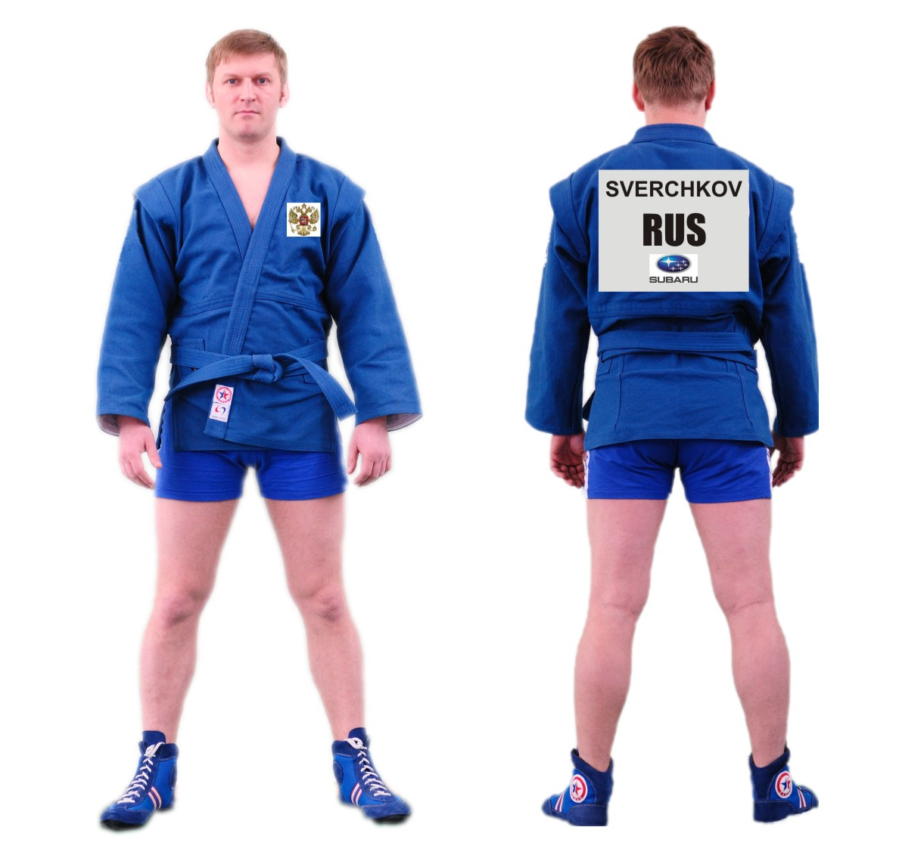
SAMBO jacket
SAMBO Shorts
SAMBO Shoes
Patch
Country emblem 9х9 cm

Patch
SURNAME
Country Code
SPONSOR
35х30 cm
SPORTS SAMBO CONTESTANT’S DRESS
Appendix 8
PETROV

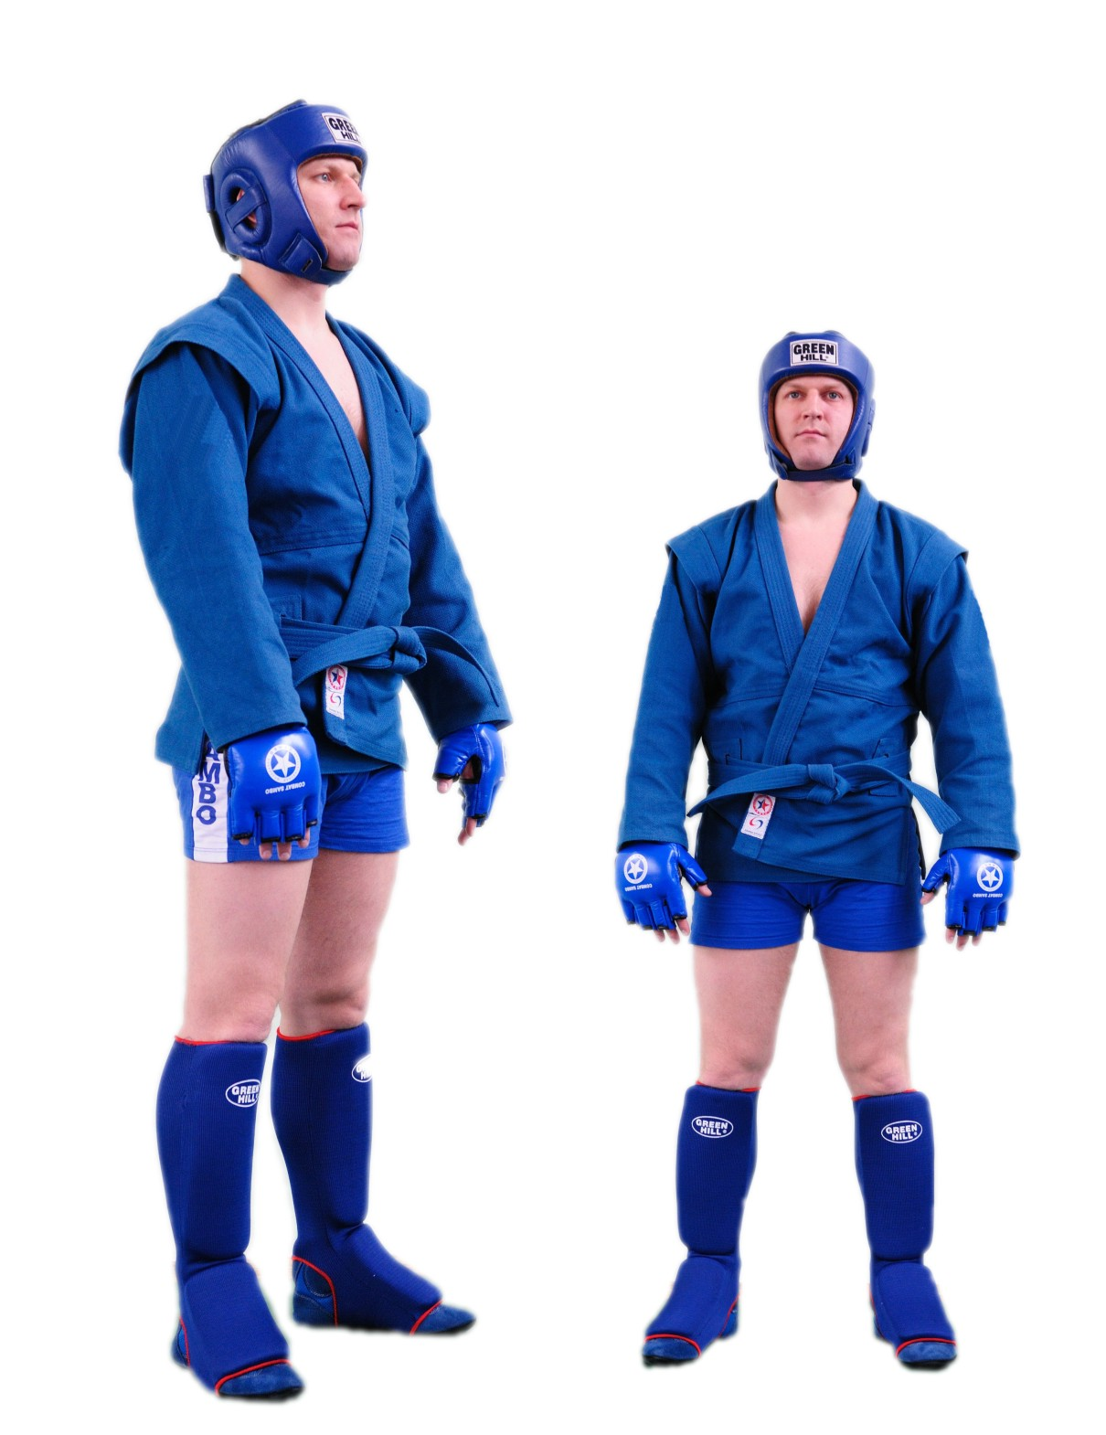
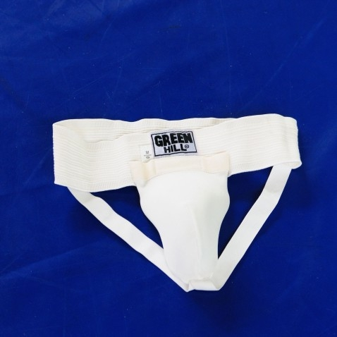
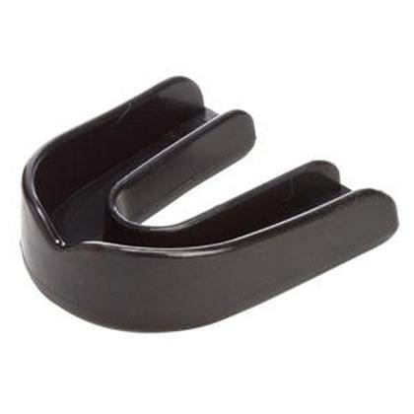
COMBAT SAMBO CONTESTANT’S DRESS
GUM SHIELD
SUPPORT
(GROIN PROTECTION)
SAMBO HELMET
SAMBO JACKET
SAMBO SHORTS
SAMBO GLOVES
SAMBO LEG PADS
SAMBO BOOTS
Appendix 9

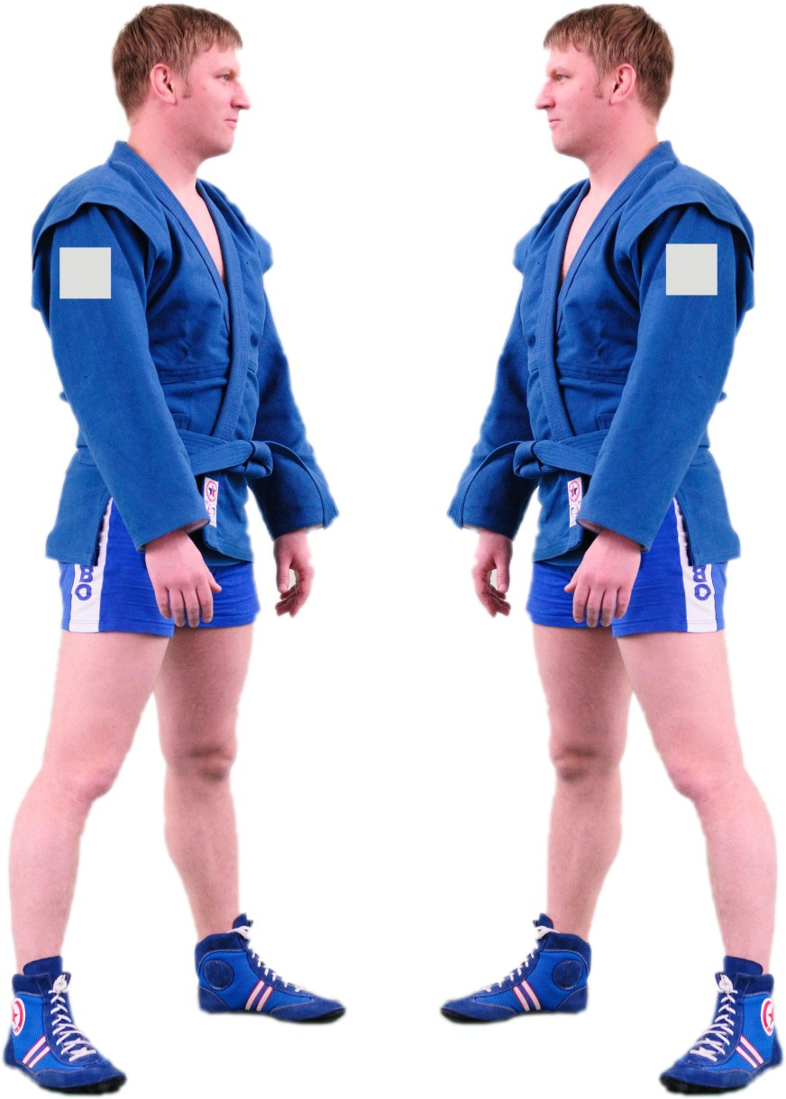
Patch 9х9 cm
Sponsors ads
ADVERTISING PATCHES ON THE CONTESTANTS’ SAMBO JACKETS
Appendix 10

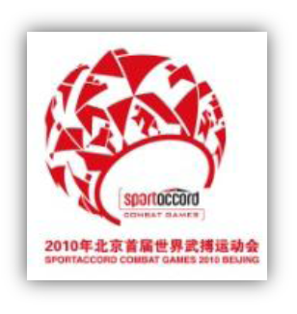

Appendix 11
SIZES AND EXECUTION OF PATCHES FOR SAMBO JACKETS

30 cm
2 cm
5 cm
2 cm
9 cm
12cm
IVANOVA
RUS
35 cm

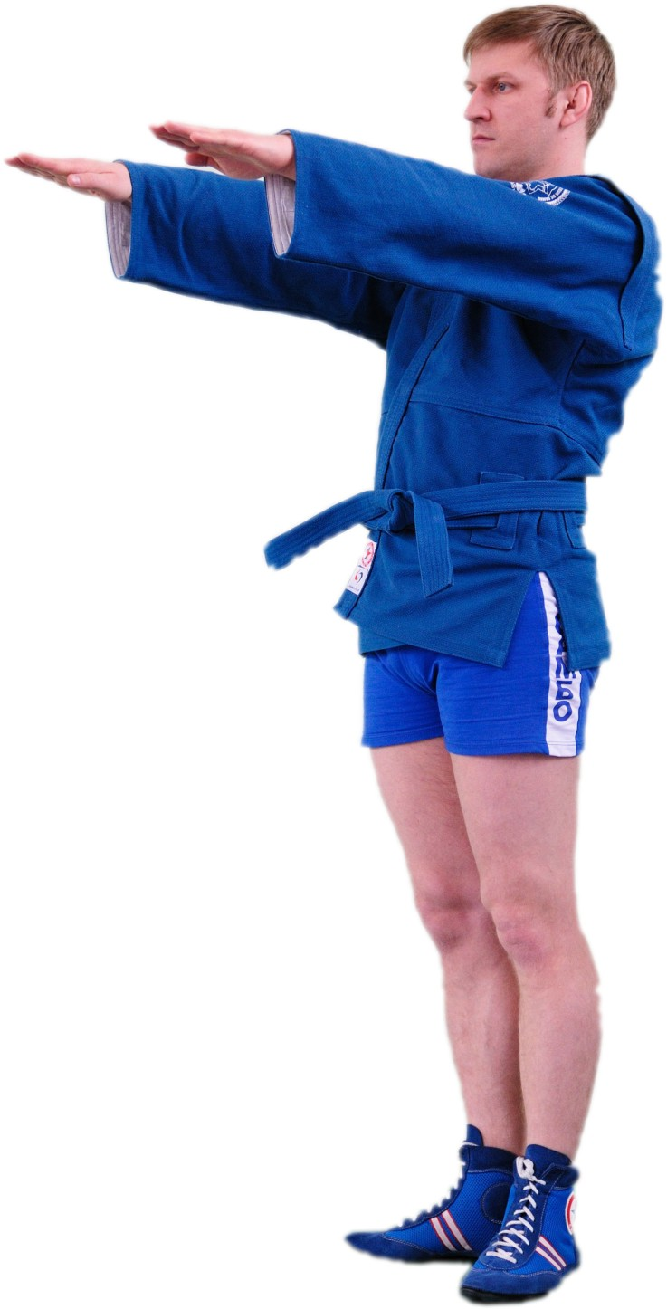
Appendix 12
SAMBO CONTESTANTS’ UNIFORM CONTROL
Gap between the arm and the tissue not less than 10 cm
1/3
1/3
1/3
15 cm
The laps of the jacket shall be 20-25 cm lower than the belt
10 см
The SAMBO jacket shall be of red and blue color of special cut and the belt made of some cotton fabric. To run the belt through there shall be two holes at the distance of 5 cm, before and behind of the side seam. The belt shall be put through these holes twice and tightly embrace the body and tied in front by the knot, fastening together its both loops. The ends of the tied belt shall not exceed 15 cm. The laps of the jacket shall be 20-25 cm lower than the belt.
The SAMBO shoes shall be made of soft leather with a soft sole and without any protruding stiff parts. All the seams should be closed up inside.
The SAMBO shorts for the SAMBO contestants shall be made of woolen, half-woolen or synthetic jersey of red or blue color. Their upper part shall reach the waist line and the lowest one shall cover one third of a hip.
At all the official competitions jackets with FIAS emblem (patent) are allowed to use.

Appendix 13
SCHEME OF PLACING DIFFERENT CATEGORIES OF PARTICIPANTS IN THE SAMBO EVENT COMPETITION AREA
VIP box
Referees
(10 per mat)

Mat Chairman and SVP

Spectators’ Stand

Spectators’ stand
Contestants’ stand
Photo area
PRESS BOX
Commentators
Viewer seats
Seats for representatives of continental and national federations
Spectators’ stand

Spectators’ stand

Secretarial group

Mat announcers 1, 2, 3

Medical personnel

Medical personnel

Chief Referee

1
2
3
Приложение 27

Main camera

SCHEME OF TV CAMERA POSITIONS IN THE SAMBO COMPETITION AREA
TV-interview area
Stationary cameras
Mobile camera
Appendix 14
VIP box

Spectators’ stand

Spectators’ stand

Contestants’ stand

Photo area

PRESS BOX
Commentators
Viewer seats
Seats for representatives of continental and national federations
Spectators’ stand

Spectators’ stand

1
2
3

Appendix 15
VIP BOX
Spectators’ stand

Spectators’ stand

Contestants’ stand

Photo area
PRESS BOX
Commentators
Viewer seats
Seats for representatives of continental and national federations

Spectators’ stand

Spectators’ stand

1
2
3
SCHEME OF INVENTORY AND SAMBO COMPETITION AREA EQUIPMENT
Podium 23 х 3 м, h=1,5м

Podium
h=1,0м (max)

3 SAMBO mats
12х12 m
Electronic boards
2 for each mat
Coach chair

Attendant’s chair

Referee video control cameras
Side referee chair

Appendix 16
VIP box
Spectators’ stand

Spectators’ stand

Contestants’ stand

PHOTO area
PRESS BOX
Commentators
Viewer seats
Seats for representatives of continental and national federations

Spectators’ stand

Spectators’ stand

1
2
3
SCHEME OF ATHLETES’ MOVEMENT IN THE SAMBO COMPETITION AREA
Dress control area
TV-interview area
MIXED AREA
Warm-up gym

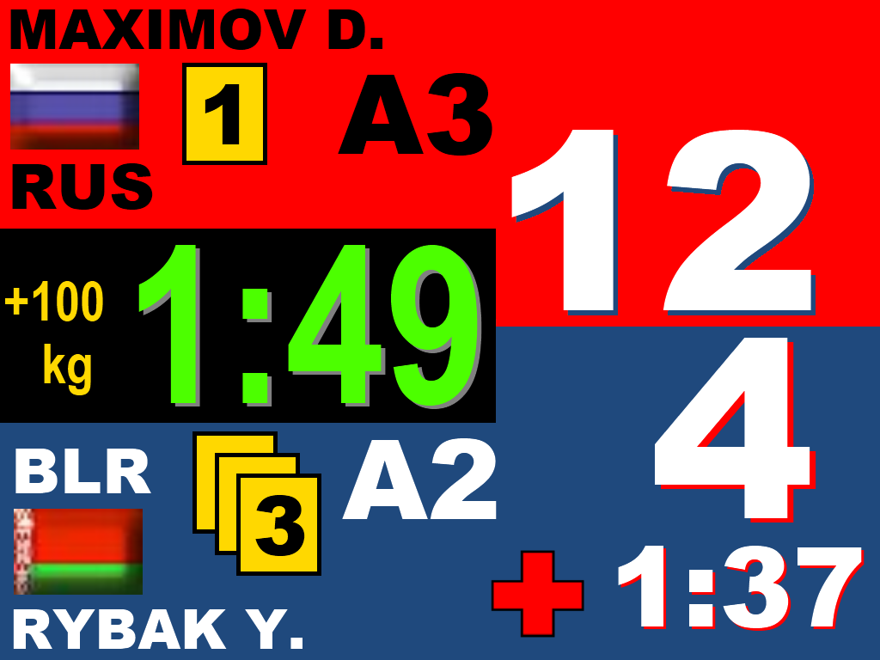
Appendix 17
IVANOV I.
PETROV A.

